 

**2016 NEWSLETTER No 1**

We hope that your school has enjoyed a positive and productive start to the 2016 school year. Where did Term 1 go?

We are delighted to advise that the **Mungo Youth Project** (MYP) conference is scheduled for Wed 31st August to Fri 2nd of September **2016**.

We apologise for the late notice, due in the main to funding challenges, however, we hope that this scheduling allows schools time to plan well and actively participate.

All Mungo Youth Project conferences have been sold out successes. We do expect the same for the 2016 conference, our fifth.

For a refresher as to the conference, or if you’re new to this significant cultural project please visit: [**http://www.abc.net.au/local/videos/2011/10/26/3348576.htm**](http://www.abc.net.au/local/videos/2011/10/26/3348576.htm)

We expect the 2016 conference to be a success as we already have enquiries from over 30 schools!

Further, the NSW Premier the Hon. Mike Baird MP has provided his endorsement which is attached.

Major sponsors are engaging which is essential.

Due to limited funding availability we are making an important adjustment to the costs of participation.

Student participation is set at $300 per student.

In setting that fee it is important to note that funding *support will be available*, based on need, AND on application.

The limit of students is ten (10) per school.

**Commended Reading: https://theconversation.com/why-our-kids-should-learn-aboriginal-history-24196**

**REGISTRATION FOR THE 2016 CONFERENCE WILL OPEN MONDAY MAY 2ND VIA OUR WEB PAGE: mungoyouthproject.com.au:**

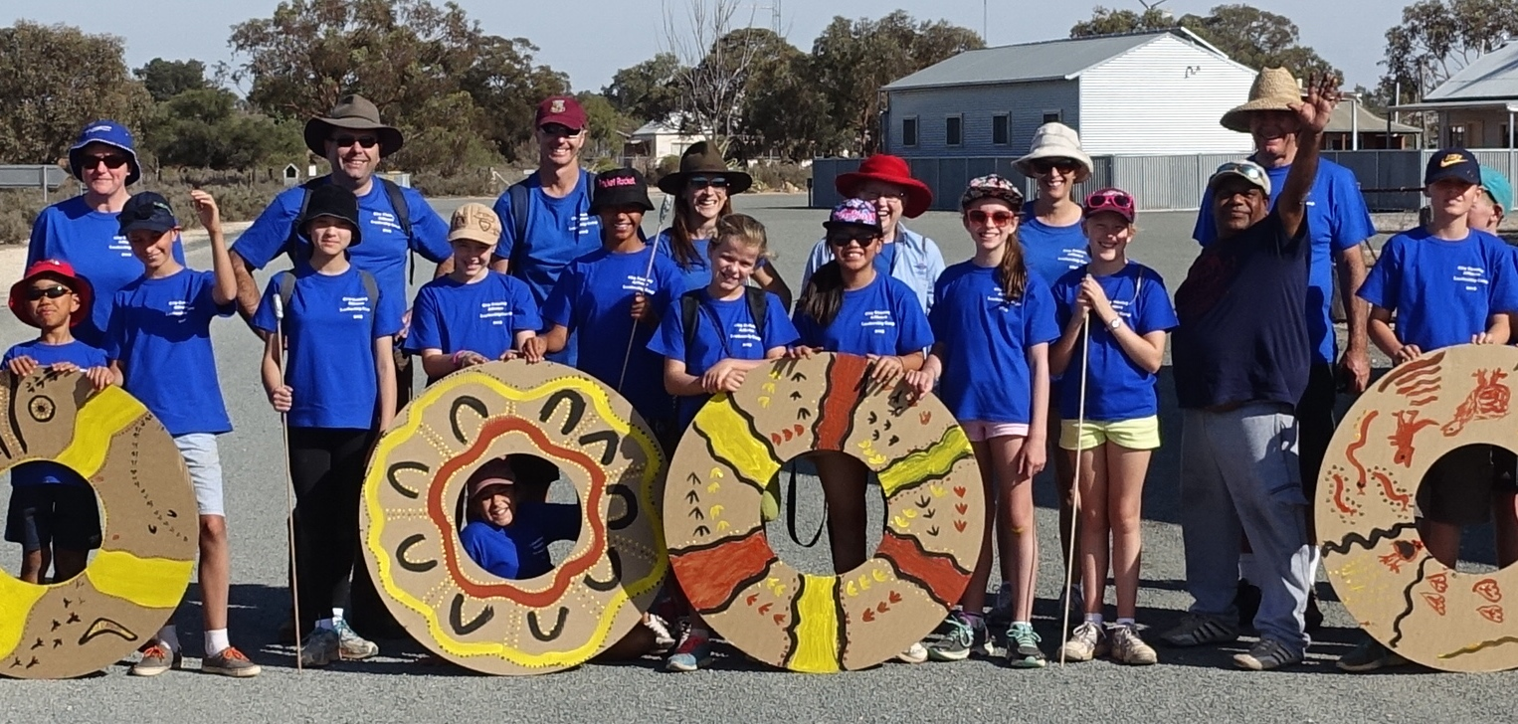

* Bree Wakefield, EVENT MANAGER [breewakefield_1@hotmail.com](mailto:breewakefield_1@hotmail.com)
* Robert Biggs, Chair, Mungo Youth Project [robbiggs99@bigpond.com](mailto:robbiggs99@bigpond.com)
* Warren Clark, Executive Officer – Mungo Joint Management [warren.clark@environment.nsw.gov.au](mailto:warren.clark@environment.nsw.gov.au)